Task:

A new customer placed an order.

A customer places an order for 100 units of Item A.

Create a sales order, here price selected at the order level should be a $320.

Ship the 2 partial shipments of 50 units each.

generate a single invoice and include both shipments in that invoice.

Receive the full payment for the invoice.

**1. Creating a New Customer**

Navigation Path: Navigation Menu > BP > Customer

Steps:

1. Navigate to the Customer section under BP (Business Partners).

2. Click on New to create a new customer.

3. Enter the Customer Code as `ANGCUSTOMER`.

4. Fill in the important fields, including the customer name, address, and contact details.

5. Set the Category to `Angolan customers`.

6. Save the customer details.

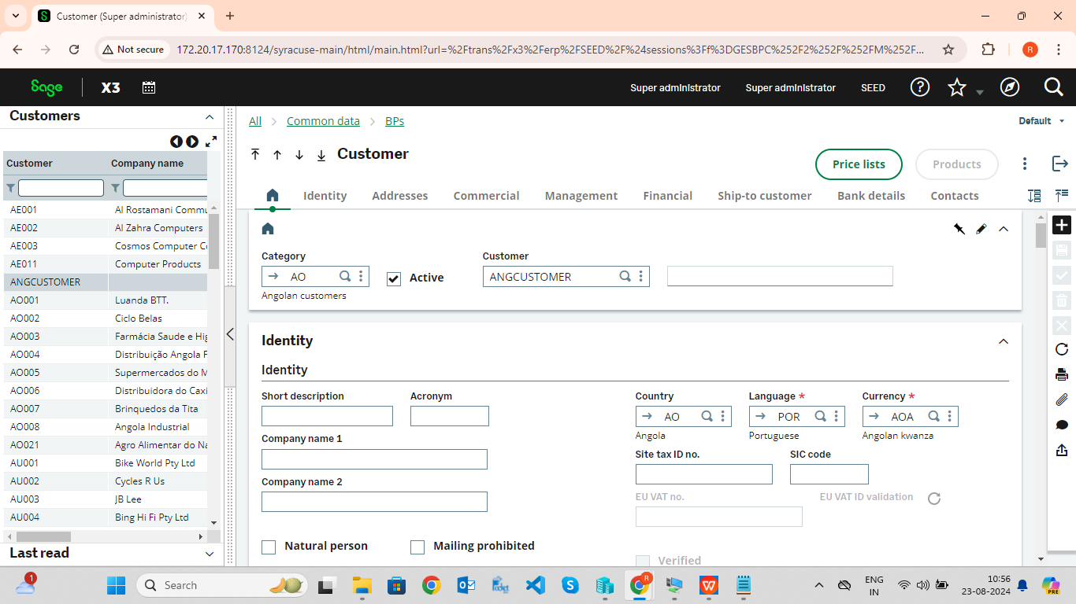

**2. Creating a Product**

Navigation Path: Navigation Menu > BP > Product

Steps:

1. Navigate to the Product section under BP.

2. Click on New to create a new product.

3. Enter the Product Code as `ACER Laptop`.

4. Set the Product Category to `finis AEO12`.

5. Specify the Product Site as `ATO11`.

6. Enter other necessary details such as description, unit of measure, and price.

7. Set the Shipment Site to `AOo112`.

8. Save the product details.

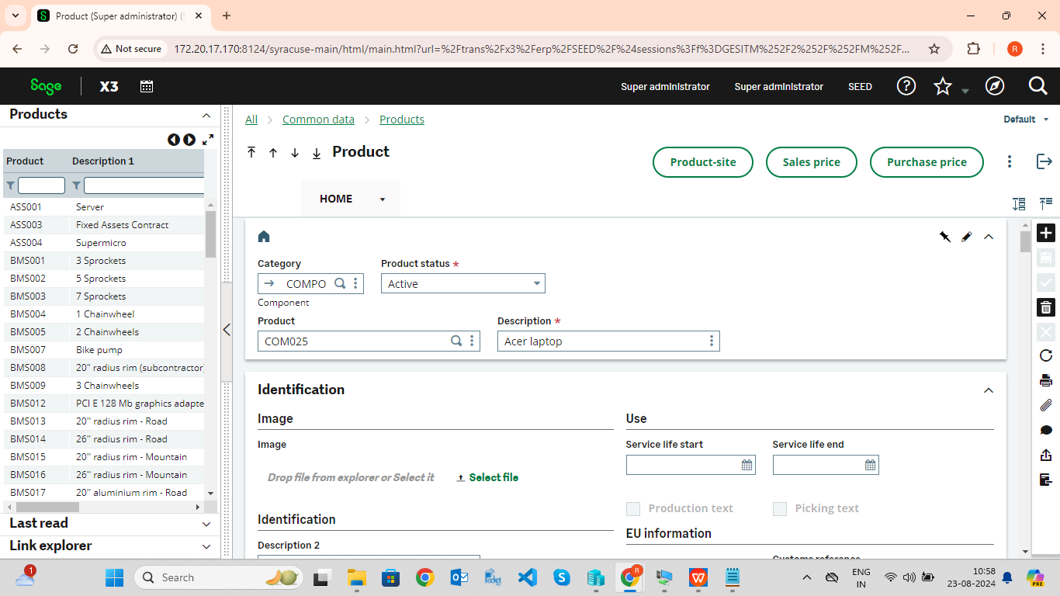

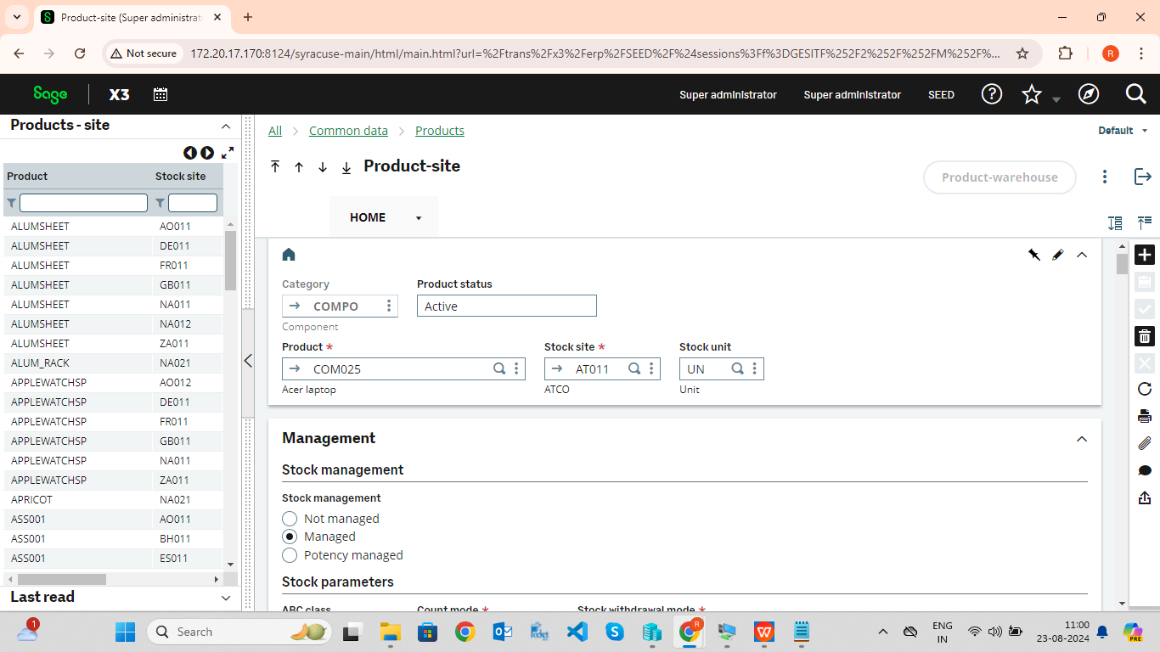

**3. Creating a Supplier**

Navigation Path:Navigation Menu > BP > Supplier

Steps:

1. Navigate to the Supplier section under BP.

2. Click on New to create a new supplier.

3. Enter the Supplier Code as `AEO11`.

4. Fill in the important fields, including supplier name, address, and contact information.

5. Save the supplier details.

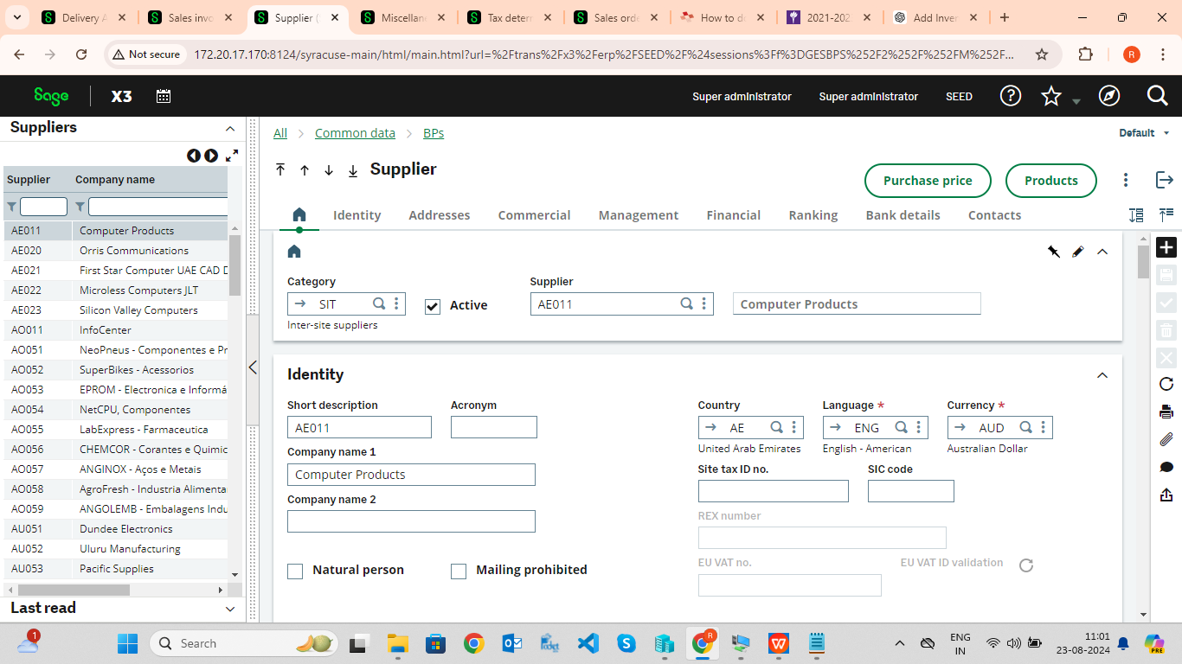

**4. Updating Stock with Miscellaneous Receipt**

Navigation Path: Navigation Menu > Stock > Receipt/Issue Transactions

Steps:

1. Navigate to the Receipt/Issue Transactions section under Stock.

2. Click on Miscellaneous Receipt to add stock.

3. Enter the Entry Number as `MRCAO0110007`.

4. Select the Product as `ACER Laptop`.

5. Set the Quantity to `100` units.

6. Fill in other required fields, such as warehouse location and lot number (if applicable).

7. Validate and save the transaction to update the stock.

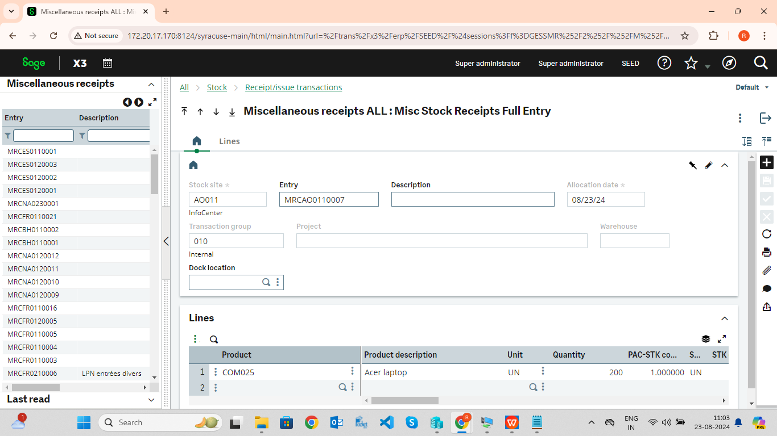

**5. Determining Tax**

Navigation Path:

Navigation Menu > Common Data > Common Tables > Taxes

Steps:

1. Navigate to the Taxes section under Common Data.

2. Click on New to create a tax determination.

3. Enter the Tax Determination Code as `SPIC_STD`.

4. Fill in the necessary fields, such as tax rate, tax basis, and applicable regions.

5. Save the tax determination.

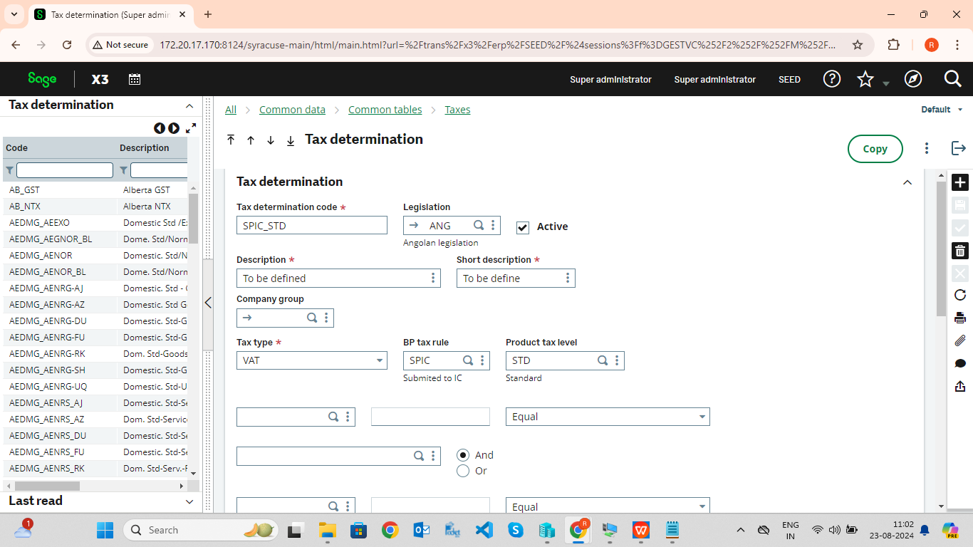

**6. Placing the Sales Order**

Navigation Path: Navigation Menu > Sales > Orders

Steps:

1. Navigate to the Orders section under Sales.

2. Click on New to create a new sales order.

3. Enter the Sales Order Number as `SONAO0110030`.

4. Select Sold-to as `ANGCUSTOMER`.

5. Set the Invoicing method to `Manual`.

6. Under the Lines tab, add the product `ACER Laptop`.

7. Set the Quantity to `100` units and the Unit Price to `$320`.

8. Save the sales order.

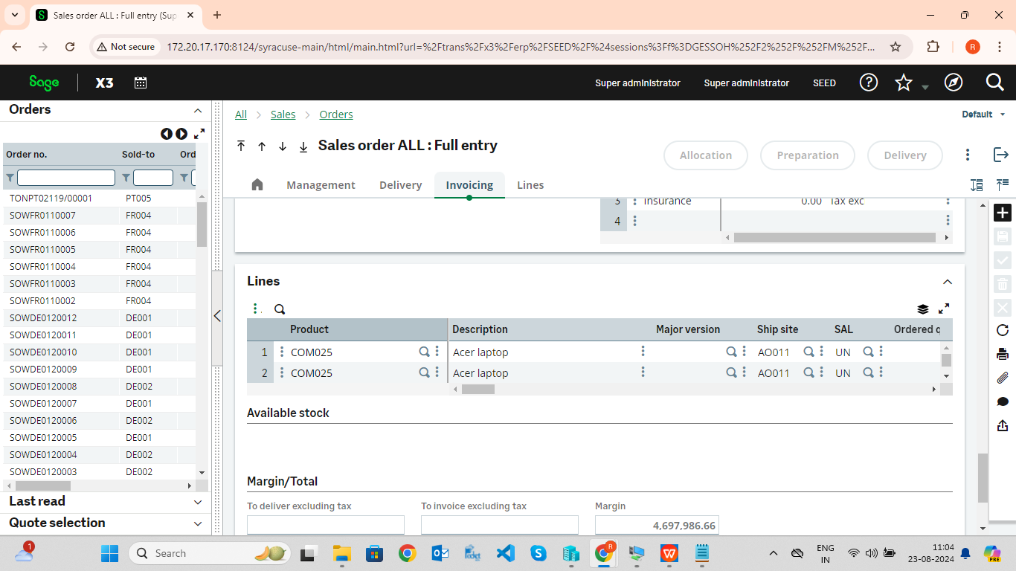

**7. Processing the Delivery (Partial Shipments**)

Navigation Path: Navigation Menu > Sales > Deliveries

Steps:

1. After saving the sales order, click on the Delivery button from the sales order screen.

2. For the first shipment, enter the Delivery Number as `SHPAO011033`.

3. Set the Quantity to `50` units.

4. Validate and save the delivery.

5. Repeat the process for the second shipment of `50` units.

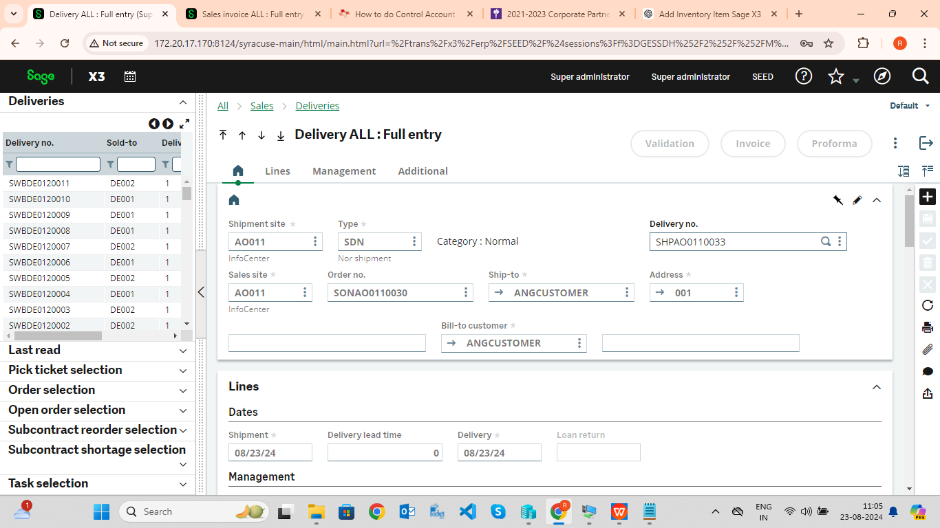

**8. Generating a Single Invoice for Both Shipments**

Navigation Path: Navigation Menu > Sales > Invoices

Steps:

1. Navigate to the Invoices section under Sales.

2. Click on New to create a new invoice.

3. Select Customer as `ANGCUSTOMER`.

4. Under the Lines tab, link both deliveries (`SHPAO011033` and the second delivery) to the invoice.

5. Validate and save the invoice.

